Title Using Book Antiqua 14, (Bold)

The first author’s name¹*, The second author’s name², and so on
Name of agency here
Corresponding Author: Author name email name
A R T I C L E I N F O | A B S T R A C T
Keywords: Maximum five keywords here, separated by a comma  Received : Date, Month  Revised : Date, Month  Accepted: Date, Month  ©2023 The Author(s): This is an open-access article distributed under the terms of the Creative Commons Atribusi 4.0 Internasional.   | English abstract only consisted of one paragraph and a maximum of 120 words. The abstract should contain the aims of the research or your paper contribution to the knowledge (novelty if available). State your tested variables or concepts if qualitative, a short explanation of your research methodology and samples, as well as your data observation timelines. Close the abstract with a short statement of your results and implications, if any.
MAXIMUM ARTICLE LENGTH BETWEEN 10 TO 20 PAGES, INCLUDING REFERENCES. PLEASE REMEMBER; EXCELLENT ARTICLES ARE JUST TO THE POINT. UP TO 30% OF THE ARTICLE CONTENT SHOULD INCLUDE INTRODUCTION TO THE METHODOLOGY, AND THE REST, 70% OF THEM, IS TO Elaborate RESULTS OF SERVICE IN THE RESULTS AND DISCUSSION SECTION, AND REFERENCES.

INTRODUCTION
The introductory section is here; You can provide logical and phenomenological reasons for conducting your research. You are also required to provide a clear explanation of the contribution of your paper to knowledge enrichment. It could be present in the description of a niche sample (capturing a unique sample), theory enrichment, or an interesting result (novelty if available). A brief and direct introduction to the subject matter is very important in this research.
You must type with Book Antiqua 12, single spaced, and justified. At the end of this section, you should give us your objectives or research questions, but remember, don't give them numbers, just put them in one paragraph or combine them with other parts of the introduction.

LITERATURE REVIEW
The theory name here
Explanation of theory here
If your work is quantitative, please provide previous research that agrees or rejects your proposed hypothesis.
H1: Hypothesis one and so on here

The theory name here
Explanation of theory here
H2: Hypothesis two and so on here

After the hypothesis section, if your study is quantitative, please provide a contextual framework here, or your mind map, if qualitative.

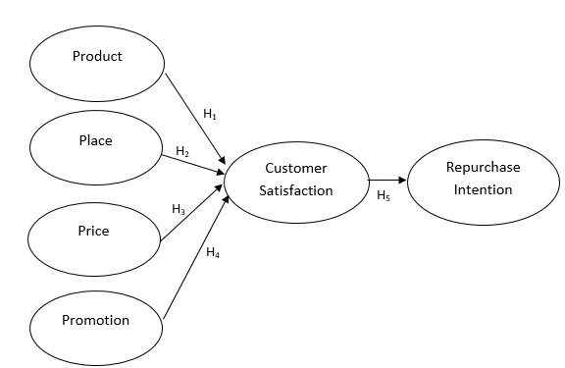

Figure 1. Conceptual Framework (images must be in good quality)

METHODOLOGY
Provide clear and concise versions of your methods of conducting research, population and samples, and data analysis tools.

RESEARCH RESULT
Steps to test your results here
In this section, you should describe each step taken to complete your research. You should not include too many descriptive statistical results here; on the other hand, it should be summarized in a more readable table or graph. You should never forget the numbers for each table and chart presented in your paper.

Table 1. Three Box Method (Table in good quality and easy to understand)
Scores | Criteria
50,00 – 100,00 | Low
100,01 – 150,00 | Medium
 | High

All formulas or formulas must also be numbered.
Y= G+C+I+Nx …………… (1)
In this section, each statistical test you perform should be thoroughly explained. This section is very important to describe the research methodology used. Each statistical finding should be summarized and presented in a table or graph; not just copy-paste from your statistics tool.

DISCUSSION
This section allows you to describe your research findings academically. You may not enter figures related to your statistical tests here; instead, you should explain those numbers here. You should structure your discussion with academic support for your studies and a good explanation according to the specific area you are investigating.

CONCLUSIONS AND RECOMMENDATIONS
Provide some conclusions and implementation of the research results.

ADVANCED RESEARCH
Each study has limitations; thus, you can describe it here and briefly provide suggestions for further research.

ACKNOWLEDGMENT
This section gives you the opportunity to thank your colleagues who provided suggestions for your paper. You can also express your appreciation for the financial assistance you received, in completing this research.

REFERENCES
Every supporting study is here and follows the APA 7th referencing guide. We strongly advise you to use referencing tools like Mendeley. Write your references as follows:

Caprara, G. V., & Zimbardo, P. G. (2004). Personalizing politics: A congruency model of political preference. American Psychologist. https://doi.org/10.1037/0003-066X.59.7.581
Diener, E. (2000). Subjective well-being: The science of happiness and a proposal for a national index. American Psychologist. https://doi.org/10.1037/0003-066X.55.1.34
Haerani, S., Parmitasari, R. D. A., Aponno, E. H., & Aunalal, Z. I. (2019). Moderating effects of age on personality, driving behavior towards driving outcomes. International Journal of Human Rights in Healthcare. https://doi.org/10.1108/IJHRH-08-2017-0040
Lusardi, A., Mitchell, O. S., & Curto, V. (2010). Financial literacy among the young: Evidence and implications. National Bureau of Economic Research, 358–380. Retrieved from https://www.nber.org/papers/w15352.pdf
Sabri, M. F., & MacDonald, M. (2010). Savings Behavior and Financial Problems among College Students: The Role of Financial Literacy in Malaysia | Sabri | Cross-cultural Communication. Crosscultural Communication. https://doi.org/10.3968/j.ccc.1923670020100603.009

